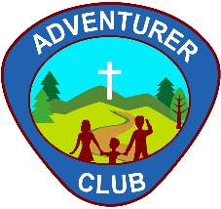
ABQ CENTRAL DAWN PATROL
ADVENTURER CLUB
2201 Estancia Dr. NW, Albuquerque, NM 87120 • (505) 836-1845 • adventurers@abqcentral.org
MEDIA RELEASE FORM
We will be taking photos/videos of your child as they participate in the Central Roadrunners Adventurer Club activities. However, we value your child’s privacy and will only use your child’s image according to your wishes. Please indicate your consent below by writing your initials only when you agree.
Initial
_________ The ABQ Central Adventurer Club may use photos of my child internally (such as in
PowerPoint presentations at our end-of-the-year celebration).
_________ The ABQ Central Adventurer Club may use photos of my child in emails and newsletters sent
to church members. No names will be used along with the photos.
_________ The ABQ Central Adventurer Club may use photos of my child on the church website,
Facebook page, and other social media accounts which will be public and available to
anyone. No names will be used along with the photos.
_________ The ABQ Central Adventurer Club may livestream and record video images of my child while
participating in church services. I understand that not agreeing to this use of my child’s
image will limit his/her participation in church services.
_________ I will raise any concerns about usage of my child’s name/image not addressed in this form
with the club Director as soon as possible.

Child’s name: _______________________________________________________________

___________________________________ __________________________________ _______________
Parent name -print Parent Signature Date

